


Chief Executive’s Report
April 2025

Contents

1. Introduction 2
2. Collaboration and partnership 5
3. Public Sector Reform 7
4. Transformation 8
5. Focused on delivery 10
6. Spotlight on… 21

If you would like this document in an accessible format, such as large print, audio recording or braille, please contact SEPA by emailing: equalities@sepa.org.uk

Introduction
Spring is upon us along with the first quarter of the financial year. As we enter April, teams across the Agency are ready for another year of protecting and helping to improve our precious environment for future generations.
Work on our Annual Operating Plan for 2025 – 2026 continues at pace and will be published shortly. The plan sets out our areas of focus for the year to drive action to safeguard Scotland’s environment. It also contains a new suite of performance objectives and key results that are important components of our new performance measurement framework. This will help us better judge how successfully we are delivering for Scotland’s environment and make sure we can be held accountable to the people and communities of Scotland.
During the reset of the Agency, we have focussed on our people, ensuring that every day they walk into a workplace that’s grounded in respect for their purpose and expertise. Our people are our greatest asset and by setting out and delivering our People Strategy, we’re enabling all our colleagues to deliver on their outcomes and make a real difference to the future of our environment.
This is evident in the launch of our Equality Mainstreaming and Outcomes Report for 2025 which demonstrates the steps we are taking to create a safe, welcoming environment, where SEPA employees feel they belong, are accepted, are heard at work and feel they are valued.
As part of our commitment to work towards the Agency becoming a more inclusive employer, we highlighted Neurodiversity Celebration Week. We want to be part of this worldwide initiative that challenges stereotypes and misconceptions around neurological differences. We promoted 24 events that colleagues could register for and attend as well as signposting to a range of helpful resources.
We asked for volunteers across the organisation to become Mental Health First Aiders as part of our strategic approach to wellbeing. We were delighted with the response and have received over 50 notes of interest. We are speaking with each individual who applied and following this will appoint 24 people to the volunteer roles. They will receive the training and support needed to ensure they have the support they need to help others in the organisation. Access to this support will be a positive step in ensuring employee wellbeing.
Coaching sessions for our Senior managers continues with sessions being held across the Agency. The feedback from managers has been positive and they are engaging well with the journey. These will continue over the coming months and include face to face sessions and tasks set between these to help embed the learning.
We also celebrated International Women's Day which has been around for over a hundred years, as have many of the issues still impacting women's advancement. The theme for 2025 was ‘Accelerate Action’. At the current rate of progress, it will take until 2158, which is roughly five generations from now, to reach full gender parity, according to data from the World Economic Forum. We celebrated the amazing achievements of some of our colleagues such as a Mount Everest Base Camp Trek and a feature on the Geomob Podcast to discuss our Satellite Emergency Mapping Service.
During Cyber Scotland week we raised awareness of cyber security with our colleagues and strengthened our collective cyber resilience. We have partnered with an organisation to bring in new training processes which we believe will significantly help. We will run attack simulation exercises and enhance our risk profile.
We had a very important week at the end of February that saw the Agency Board Chair and members of the Corporate Leadership Team, give evidence to the Net Zero, Energy and Transport Committee at the Scottish Parliament. This session covered a wide range of work that the Agency does with a focus on areas of regulatory business and compliance, assurance, our reset and programme of transformation. We provided a written statement to the committee, which you can read here and watch the session online.
We also launched SEPA’s VIBES 2025 in Parliament, our partnership Business Awards that SEPA has played a leading role in since its inception. Now more than ever we need business and environment to come together to build a sustainable future. Without doing so, we simply cannot face these threats and challenges nor take full advantage of opportunities.
Dr Alasdair Allan, Acting Minister for Climate Action, addressed the event reflecting on the commitment of the Agency to Scotland's sustainable future and of those businesses who are dedicated to putting the environment first. There were many opportunities to recognise success and highlight the innovative, collaborative work we’re delivering with a multitude of partners, delivering a multiplicity of benefits for the people of Scotland. More can be read on this later in this report.
I also had a very productive meeting with Grant Moir, Chief Executive of the Cairngorms National Park Authority at the end of February to discuss progress between our two organisations and areas for future collaboration.
This report features some highlights as our teams continue to deliver for Scotland.
For the future of our environment.

Collaboration and partnership

We recognise the impact of progressive partnerships and collaborative working across the public, private and third sectors, as well as with communities. We share service delivery so that we offer better outcomes more efficiently, and with a customer focus.
Improving sediment management in the hydropower sector
Scotland relies on hydropower for a substantial proportion of its energy generation. This contributes to the achievement of our net zero targets but can also impact on the environment when hydropower infrastructure prevents the natural movement of sediment through river systems. The supply of sediment (sand, gravels, small stones, etc) plays a vital role in river ecosystems, providing diverse habitat as well as a source of nutrients for plants and animals. When sediment gets trapped in water storage reservoirs, behind hydropower dams as well as in smaller weirs, it cannot be replenished and can result in severe erosion downstream and a loss of habitat diversity. This also creates problems for hydropower operators, as sediment is expensive to remove, and can cause damage to turbines. As we see an increase in the frequency and severity of flood events, these problems will be exacerbated.
We worked together with NatureScot and Scottish Canals to secure a year's funding of £186,000 from Scotland’s Centre of Expertise for Waters for a project to raise awareness of the importance of considering sediment management at the design stage of hydropower schemes. The steering group worked with a team from the University of Glasgow and cbec eco-engineering to produce an awareness-raising video and a report that describes the full range of sediment management options and provides a framework for identifying those options with the best environmental and economic outcomes.
We will look to incorporate this into SEPA’s Integrated Authorisation Framework guidance documents to support operators to prepare high quality permit applications and enable quick processing. The project will help us and operators to deliver improvements to the water environment, improve business environmental performance and strengthen environmental and commercial resilience to the effects of climate change.

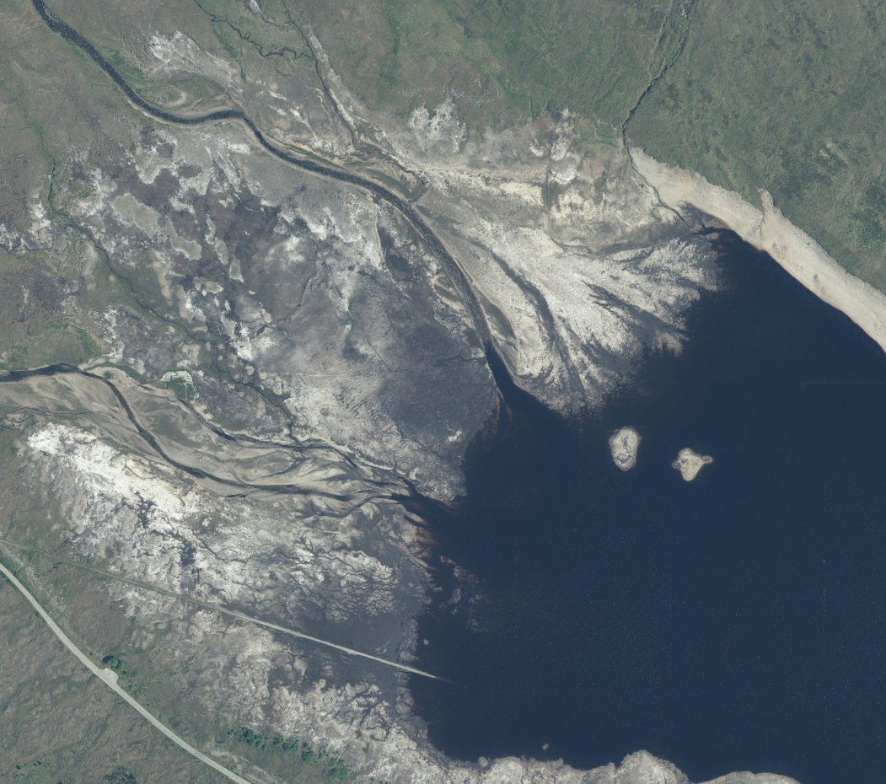  Taken from Google Maps. | 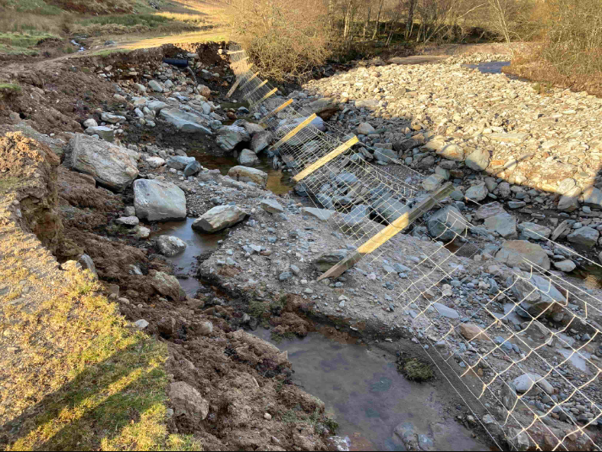

The photo to the left above, from Google Maps, shows sediment deposition approximately 800m long at upstream end of a hydropower reservoir. The photo above to the right shows Riverbed and bank erosion following a powerful flood caused by Storm Babet in October 2023.

Public Sector Reform

As a public service, we continue to respond effectively to the increasing pace of change, and we are committed to considering the best models for delivery of all our services. SEPA continues to lead and engage with a range of initiatives to further the objectives of public sector reform.
Environment Futures Group
We continue to play a leading role in Scottish Government’s Environment Public Sector Reform initiative. The environmental agencies and Scottish Government, as members of the Environment Futures Group, have agreed to trial a place-based approach to dealing with rural land-use environmental impacts and opportunities. This approach has potential to provide multiple, significant benefits including enhanced natural flood management, food security, biodiversity, water quality and water supply.
Pilot projects for the Aberdeenshire Dee and the Angus South Esk catchments are being established. These will require a greater degree of coordination and collaboration between environmental agencies as well as greater policy and funding alignment. Next steps will identify the resources required to establish this approach in both catchments, with SEPA maintaining a prominent role, particularly in the South Esk catchment where climate adaptation and improved water environment potential is high. New approaches to stakeholder and community engagement will also be trialled.

Transformation

To deliver effectively for Scotland, we need to transform areas of our organisation and embed a customer and delivery focus in everything we do. Doing so will mean we can design and offer better, more resilient services that meet the needs of our customers.
Grangemouth Regulatory Hub
In the autumn of 2023, the Grangemouth Future Industry Board began a process of restructuring to expand its membership beyond the existing public sector. This restructuring process is complete, and it now includes representatives from industry, Trade Unions, academia, and the local community. The central remit of this reconstituted Board is to develop and support the delivery of the Grangemouth Just Transition Plan. One of its workstreams is the Grangemouth Regulatory Hub, led by SEPA. The Hub’s aim is to deliver transparent, efficient, and effective regulation. Its focus will be to bring together regulators, businesses, community members and environmental organisations, to create strong partnerships and successful working relationships that support delivery of a just transition to net zero and effectively facilitate innovation in ways that protects communities and the environment.
In March, the Hub delivered a key success with the completion of a collaborative project to pilot an Outcome Based Collaborative Regulatory (OBCR) approach. OBCR is an emerging evidence-based model for regulation, in which stakeholders work together, on the basis of trust and respect, to achieve shared aims and outcomes. The work this project has delivered demonstrates that OBCR theory and learnings have potential to be applied to deliver a regulatory environment which can support communities and industry to meet regulatory obligations and better support innovation and the just transition. Practical outcomes include an actionable model of how to leverage better value and drive improved regulatory delivery through collaboration and identification of specific opportunities for an OBCR approach. As well as sharing learnings, this project leaves a legacy of practical tools and recommendations for future work. More information on the project will be published on our website shortly.
The project was made possible by a grant from the £12 million Regulators’ Pioneer Fund (RPF). The RPF is a grant based fund to enable UK regulators and local authorities to help create a UK regulatory environment that encourages business innovation and investment. The current £12m round is being delivered by the Department of Science Innovation and Technology.
Environmental Performance Assessment Scheme (EPAS)
Business environmental performance is key to ensuring we can maintain a healthy environment that can support future business opportunities and economic growth. We noted in our February report that one of our key regulatory transformation projects has been the development of a replacement for the 2009-2019 Compliance Assessment Scheme – this is our Environmental Performance Assessment Scheme. On 31 March we launched our consultation, which will run to 30 June 2025.
EPAS will enable the environmental performance of different types of regulated activities to be accessible to the public at any point in time. It has been designed to support swifter remedial action to address issues that pose an environmental risk on a continuous basis following compliance checks. Digital systems are being developed to support EPAS, bringing significant efficiencies to our compliance work.

Focused on delivery

SEPA is Scotland’s principal environmental regulator, and our purpose is to protect and improve Scotland’s environment. Our approach to deliver for Scotland focuses on what we do and our corporate plan priorities. We also continue to develop our approaches to communicate and engage effectively with all our customers, the public and communities.

Protect 
Successful prosecution outcome
Derek McAllister and C and K Removals Ltd were both referred to the Crown Office Procurator Fiscal Service by SEPA for offences relating to illegal waste deposit and disposal. The case concluded on 3 February 2025.
A confiscation order of £3000 was imposed on Derek McAllister under the Proceeds of Crime Act 2002 in addition to the previous sentence of a 150-hour community payback order and 18-month supervision requirement.
C and K Removals Ltd were admonished.
The details of the outcome were published by SEPA, Crown Office Procurator Fiscal Service and multiple other outlets, including The ENDS Report which provided a significant interventions opportunity.
Producer Responsibility – Enforcement Undertakings
An Enforcement Undertaking (EU) is an offer, made voluntarily, to make amends for non-compliance and its effects, and to prevent recurrence. In addition, an offer needs to include appropriate beneficial action, for example, by offering longer term gains through more sustainable operating practices and by bringing about benefits to communities. An Enforcement Undertaking can be offered at any time before SEPA has decided what enforcement action will be taken, even before we are aware of the non-compliance. We achieved significant successes in the first few months of 2025, using civil sanctions to remedy non-compliances with the producer responsibility obligations under packaging waste regulations. Building on four packaging Enforcement Undertakings (details of which can be viewed here (Penalties imposed and undertakings accepted | Scottish Environment Protection Agency (SEPA)) which were accepted over the previous 12 month period, a further two Enforcement undertakings have been accepted in 2025.
On 31 January 2025, SEPA accepted an Enforcement Undertaking from Mackay’s Limited who will pay £204,131 to the Scottish Forestry Trust by way of reparation for their non-compliances in 2022 and 2023. They have already paid a sum of £3,500 to cover SEPA’s investigation costs.
On 3 March 2025, Thistle Seafoods made reparations of £47,000 in total to be split between three charities (Stella’s voice, friendsofanchor and Scotlink) plus a payment of £2000 to cover SEPA’s investigation costs.
Interventions to Tackle Environmental Crime
We worked in partnership with East Renfrewshire Council to investigate allegations of a business owner fly tipping their own waste. Local authority powers limit them to issuing a Fixed Penalty Notice of £500 or referral of the case to the Crown Office Procurator Fiscal Service.
To disrupt the activity and prevent any further deposits at the locus, we attended and cautioned the alleged offender. SEPA also determined that a Variable Monetary Penalty was the most appropriate action. The Variable Monetary Penalty for £2642.01 was issued on 9 January 2025. East Renfrewshire Council reports that since our on-site intervention fly tipping at the locus has ceased.

Improve 
Celebrating VIBES 2024 winners
At the end of February, we hosted the winners of the 2024 VIBES Awards at Scottish Parliament. We brought together MSPs and members of our Corporate Leadership Team along with Scotland's leaders in environmental businesses and agencies to champion climate action across the country.
SEPA has been at the forefront of the VIBES Awards for 25 years, and we gathered the most recent inspirational winners leading the way in sustainable practice.
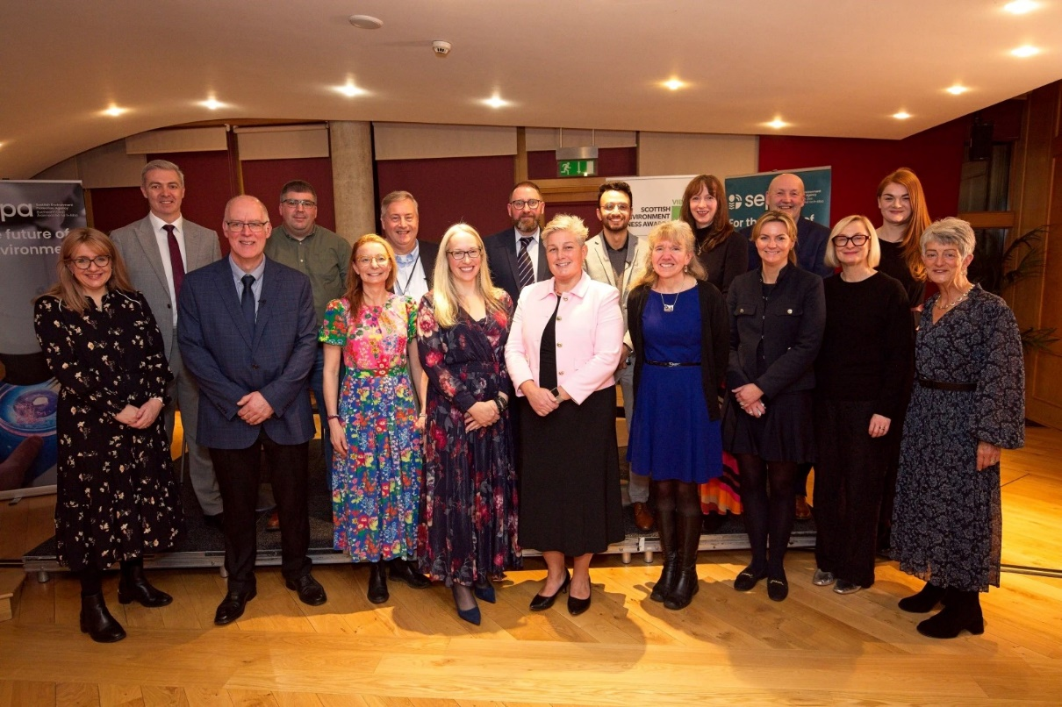
The photo above shows attendees at the VIBES 2024 awards at the Scottish Parliament.
The Awards are a partnership, led by the Agency, involving Scottish Government, Energy Saving Trust, Highland & Islands Enterprise, Scottish Enterprise, South of Scotland Enterprise, Scottish Water, Zero Waste Scotland and NatureScot. Further support is provided by CBI Scotland, the Institute of Directors, Federation of Small Businesses, Bright Green Business, Prosper and the Scotch Whisky Association. The Awards are also sponsored by several businesses/organisations.
VIBES 2024 saw the 25th anniversary of the Awards. 120 applications were received and 31 Scottish businesses shortlisted across 11 award categories. There were 11 Winners and three Commended businesses from across Scotland.
Our Chair, Lisa Tennant facilitated a panel discussion and I gave the closing remarks at this exciting and worthwhile event.
Next steps for the River Leven
Following the successful completion of the Water Environment Fund funded river restoration project at the end of 2024, the next phase of the River Leven improvements has been confirmed. Green Action Trust and partners have secured a £2.98M grant from the National Lottery Heritage Fund as part of the £5.3M River Park Programme to be delivered from May 2025 (https://www.theleven.org/projects/the-river-park/).
The photo below shows a SEPA colleague with River Park partner representatives (from Green Action Trust, Fife Coast & Countryside Trust and Fife Council) with Andy Milne from National Lottery Heritage Fund’s Scotland Committee.

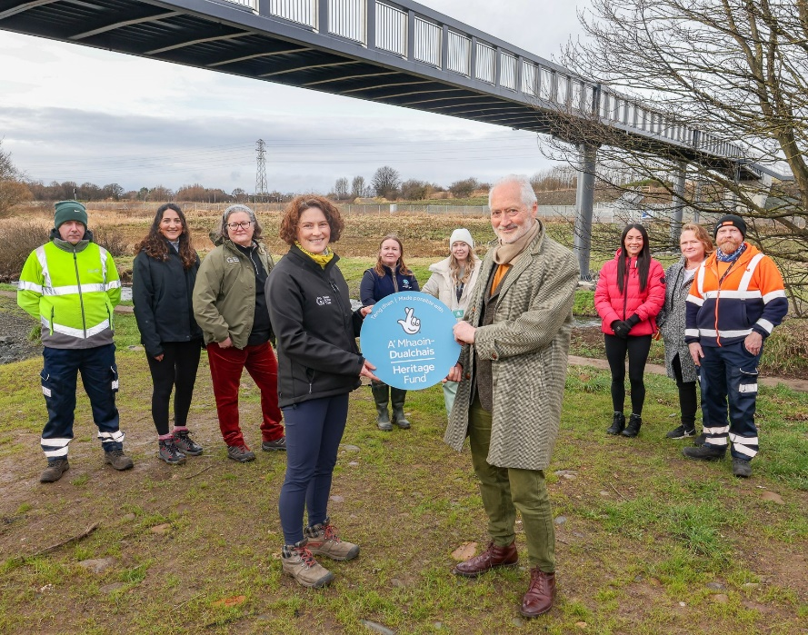
A groundbreaking project, brought to life by the SEPA-led Leven Programme, will develop a neglected site along the River Leven to deliver an accessible, attractive and biodiverse amenity space for local communities. A key focus of the park is to bring to life Levenmouth’s heritage through dedicated spaces that will encourage exploration and investigation of the area’s industrial and societal past, while delivering a Nature Network focussed on climate resilience within this riparian landscape.
Supporting Scotland's construction sector
We are committed to supporting businesses in achieving strong environmental performance while meeting their regulated responsibilities. We have launched a brand-new environmental toolkit designed specifically for Scotland's construction sector.
The initiative was part of a joint agreement with Robertson which was the first of its kind to focus on environmental performance across the entire construction supply chain.
The toolkit includes a series of environmental guidance notes and supporting videos reflecting different learning styles and providing practical advice on compliance waste reduction and sustainable building practices. The resources are freely available and cover key environmental topics such as air quality and nuisance, cement concrete and grout, decarbonisation on site and material sourcing and management. For further information please see here.
Working with Robertson, we identified the key compliance issues we wanted to tackle. A range of our specialists, external supply chain members and NetRegs colleagues contributed to making these resources accurate, accessible and engaging.
Material Facilities
Recycling quantity and quality sampling and reporting changed on 01 April 2025 when the new Code of Practice for material facilities comes into effect. SEPA will be the regulatory authority assessing compliance with the Code. The new Code obliges waste operators to generate significantly improved waste recycling data by increasing sampling frequency and introducing sampling requirements for more types of waste materials. The Code also brings additional transfer stations and bulking facilities into scope. This will result in more waste streams being sampled more frequently at more sites. The data gathered supports the transformation of the Packaging Extended Producer Responsibility (PEPR) system by Scottish Government and the other governments of the UK. This is part of the work to build a more circular economy and address the global climate emergency.
PEPR is intended to ensure that packaging producers, those who place this material on the market in the first place, pay the cost of managing packaging waste at the end of its life in the UK and requires them to achieve high recycling rates. Producers pay a disposal fee that is based on the amount and type of packaging they supply. As part of the recent transformation of PEPR, a proportion the collected disposal fees will be paid to local authorities to fund their management of household packaging waste. PackUK has been established by DEFRA on behalf of the four UK nations to oversee the payment of fees to local authorities and administer other aspects of PEPR work. The data collected from sampling required by the Materials Facilities Code of Practice is one factor in the local authority payment calculation which, for Scottish local authorities, DEFRA has estimated will pay between £1.2 and £19 million per council per year depending on the size of the local authority and the costs associated with their packaging waste collection effort. Following engagement with the waste management industry and other work done in the run up to 31March 2025, we have now completed our preparations and are ready to receive, process and report recyclate quality data under the new Code.

Adapt 
Water of Leith Pilot – Flood Asset information
Understanding how Scotland’s flood defences are operating and performing is vital for reducing flood risk, safeguarding lives and minimising economic damages. We have recently completed a successful pilot project on the Water of Leith Flood Protection Scheme to better understand the need for Flood Asset data in delivering Scotland’s Flood Resilience Strategy.
We worked in partnership with Edinburgh City Council and an external business to explore the benefits and opportunities of developing a database containing consistent and comprehensive information held about Scotland’s Flood Assets. This included understanding the power of asset information in telling us the benefits of flood defences to the community and economy, how we can best represent these on maps and risk information, the minimum data standards for flood assets and how this information can best target investment and maintenance of flood assets in Scotland.
This information was presented to Scottish Government and is being used to inform the future Flood Advisory Service work and the implementation of Scotland’s Flood Resilience Strategy.
We are developing further work this year with Scottish Government to establish a database for all flood assets and carry out more detailed asset assessments in priority areas to support a more accurate flood forecasting and warning service.
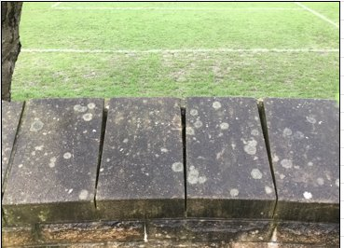
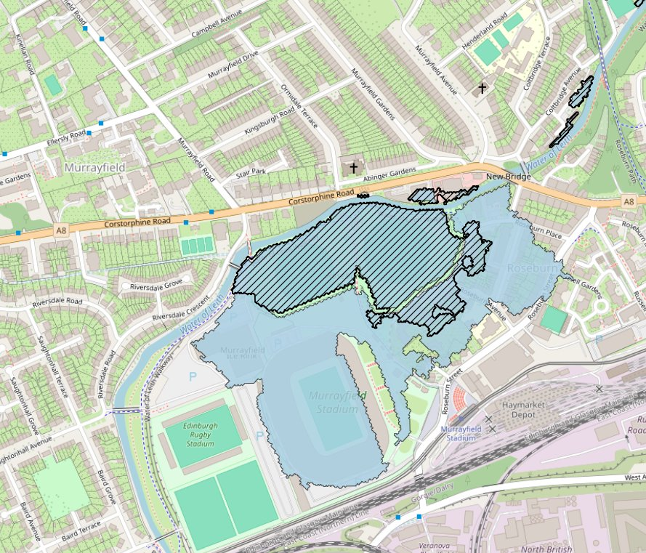
The hatched area of the map shows the flood outline for the scheme at the design standard of protection (1:200 year flood). The wider blue area is the 200 year flood outline for one of the asset failure scenarios. The photo shows the condition of the wall in this area – the Local Authority will use this in support of their asset maintenance programme.

Avoid 
“Pluvial” (Surface Water and Small Watercourse) Flood Maps Publication
Flooding is Scotland’s biggest climate adaptation challenge. With more intense storms and heavier rainfall, surface water is Scotland’s biggest flood risk. Surface water happens when drains and small watercourses are overwhelmed by intense rainfall. It can affect communities and transport routes far from any river. The publication of these new SEPA flood maps incorporates the latest science and evidence, new datasets and the latest climate change projections in our assessment of the impact of surface water flooding, which includes for the first time small watercourses.
We worked in partnership with others, externally and across the organisation to deliver the product on time, under budget and to our specification, utilising UK industry experts in this area. It is the culmination of several years of working across the organisation to reach this milestone.
These maps help homeowners, businesses, and communities understand how flooding can affect their area both now and in the future, giving them time to prepare and build resilience. Local authorities and planning authorities can also use the maps to make informed decisions about flood management and infrastructure.
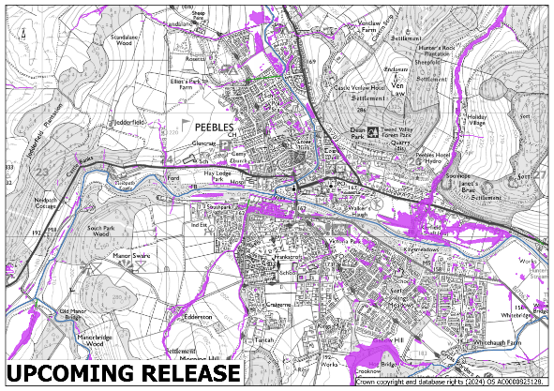

10 Years of Scottish Landfill Tax, millions of tonnes of waste diverted from landfill
On 1 April 2015, we begun a new venture, to undertake compliance work on Scottish Landfill Tax on behalf of Revenue Scotland. UK landfill tax started in 1996 and is recognised as one of the most successful environmental policies. It was then devolved to Scotland as one of two taxes in 2015, the first tax to be separately collected in Scotland for over 300 years.
10 years on, we still have a strong partnership with Revenue Scotland with a team dedicated to Scottish Landfill Tax and the Scottish Landfill Communities Fund (SLCF).
- Waste disposed of by landfill is now less than half of what it was in 2015 and is set to fall further at the end of 2025 when the biodegradable municipal waste (BMW) ban comes in. Over 4 million tonnes were disposed of in 2015, to nearer 1 million tonnes today.
- Over a £1 billion in landfill tax has been collected for Scottish Public Services
- £69 million of tax credit has been donated to community projects
- We provide cross organisation support to Revenue Scotland.
- As the waste landscape changes, more material is going to incinerators at waste to energy plants, rather than disposal at landfill sites.
Despite the success of landfill tax, we are aware of potentially negative impacts of a higher than ever increase in the rate of Scottish Landfill Tax from 1 April 2025 and approaching BMW ban.
Precautions are being taken against the potential of increased illegal waste activity and the increased chance for landfill operators’ businesses to struggle financially and fail. The Scottish Landfill Communities fund is currently being consulted on by the Scottish Government, as with reduced waste going to landfill and reduced landfill tax being paid, the SLCF may not be viable beyond 2025-2026.

Warn 

Updated flooding information communication
SEPA has refreshed how we communicate our flood warning and information tools to the public. This has been informed by a user-led approach. Our focus on accessibility ensures that communities understand how they can be exposed to flooding and know how to build resilience.
Our recent winter flooding campaign aims to support people and communities in becoming more prepared, ensuring they know how to access and understand the tools and information we provide. Additionally, we aim to motivate them to take the necessary actions to respond effectively.
The campaign had a focus on community engagement, and we hosted our first ever national community event online. The event was well received with over 65 attendees from communities across Scotland and 96% of participants stating they felt better informed about how their community could prepare for flooding. It was clear that people and communities affected by or at risk of flooding are eager to participate in such events and appreciate the valuable information provided to support them.
As part of our refreshed approach, we have developed a distinct flooding identity within our corporate brand and introduced a new call to action: sepa.scot/flooding. This ensures a consistent user experience across a dynamic digital landscape, while providing all flood warning and information resources in one place.

To improve communication, we developed new campaign key messages through a series of internal and external workshops. Using these insights, we created fresh online and offline assets that ensure consistency and recognition of our flooding information across all channels.
We equipped our colleagues with the information to be prepared, recognising that many travel for work or live in areas at risk of flooding themselves.
A comprehensive campaign evaluation was undertaken showing that we met most of our key performance indicators established, including a 4% increase in Floodline customers, over 100% increase in traffic to sepa.scot/flooding and a 5% increase in social media engagement across our channels, with video content performing well. External factors relating to the global perception and use of X has impacted our @SEPAFlood channel and contributed to this KPI not being fully achieved with an increase of 3% in followers instead of the targeted 5%.
Our key messages and call to action will continue to be embedded across our channels and performance evaluated in our ongoing reporting of social content, media coverage, newsletter engagement and our internal stories.
Risk of water scarcity this summer
In early March we published our quarterly water situation report that reviews how the weather conditions over the autumn and winter have impacted water resources across Scotland.
The headline message is that despite intermittent wet spells, rainfall has been below average over winter for much of the country. This follows a particularly dry autumn - the 5th driest autumn in 100 years according to the Met Office. This means without significant above average rainfall in spring and summer, there is an increased risk of water scarcity.
Dry conditions have continued throughout March and we have published an additional update report to highlight the increasing risk so early in the season. This shows that most areas of Scotland are already at “early warning” of water scarcity. Parts of Angus and Fife have now seen 10 straight months of below-average rainfall, receiving less than half of what’s normal for March.
Our external communications are highlighting the escalating risk and urging businesses to take action now to manage their water use and consider operational resilience. Our weekly water scarcity reporting starts after Easter, which outlines the risk of water scarcity across the country and gives information and advice on action water users should take. We’re continuing to prepare internally through our monitoring, evidence analysis, reporting and operational response groups so that we can support regulatory action to protect the water environment. We are also continuing to provide advice and guidance for water users to help them manage the situation through our reporting, communications and working closely with Scottish Government, businesses and key stakeholders such as the agricultural sector, industry and Scottish Water.
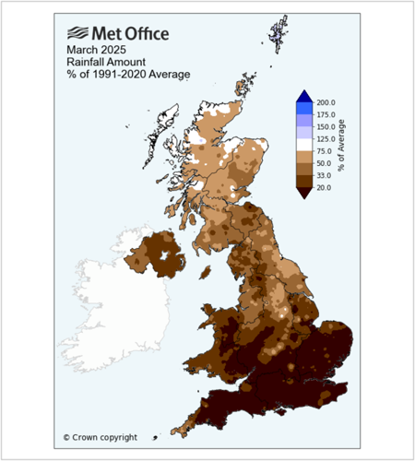
The image to the left is a map produced by the Met Office which shows the 2025 March rainfall amount as a percentage of the 1991-2020 average.

Spotlight on…
Our purposefully passionate people
Scottish Chief Finance Officer awards
The Scottish Chief Finance Officer awards celebrate creative thinking, strategic influence and demonstration of leadership. The exceptional talent of Chief Finance Officers and their teams was recognised in the second year of the awards. A few team members were able to celebrate SEPA achievements at the ceremony which were held in Glasgow at the end of March
SEPA colleagues were shortlisted for two categories at the Scottish Chief Financial Officer Awards - Scottish Chief Finance Officer of the Year 2024 of a Not-for-Profit organisation and our Finance & Procurement teams for Team of the Year. This recognition is testament to their hard work supporting SEPA as we focus on organisational sustainability and providing value as a public body.
We are delighted that Angela Milloy, Chief Officer; Finance, Modernisation & Digital won the award for Chief Financial Officer of the Year 2024 of a Not-for-profit Organisation.
SEPA wins two National FOI awards
We were presented with two awards at the 2025 eCase Freedom of Information (FOI) Awards by Scottish Information Commissioner David Hamilton.
This is the third year of the awards, which celebrate the best in FOI practice from across the UK public sector. Other nominated organisations included Scottish Government, Environment Agency, as well as a number of local authorities and NHS trusts.
Senior Information Officer Alicia Jones was a joint winner for Practitioner of the Year, which celebrates outstanding achievement in the delivery or promotion of FOI best practice. Alicia has been integral in driving process change and supporting colleagues in her team and across the organisation to deliver an excellent service.
We were also presented with a Highly Commended award in the Team of the Year category. This is awarded for embodying values of openness and transparency by embedding transparency in their organisation, by significantly improving service or delivering an exemplary service.
The photograph below (left), shared by eCase, is of the Highly Commended Team of the Year presentation, and below (right) are members of the Access to Information team.
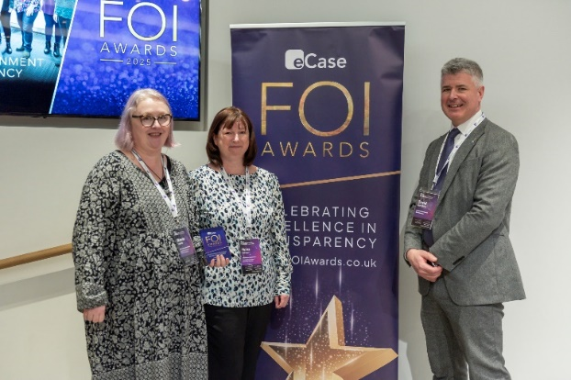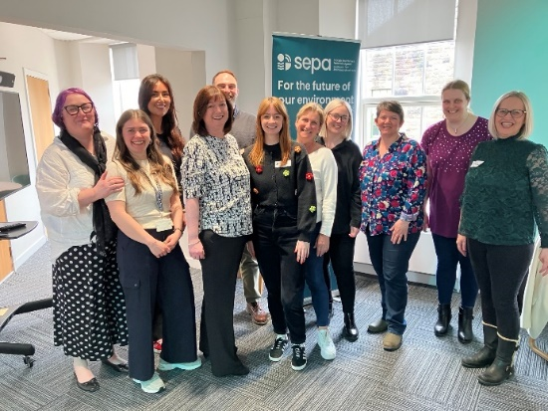
This celebrates not just the hard work and commitment of the Access to Information team but also the recognition of colleagues across SEPA, including the support of Senior Leaders and the Board to improve and maintain SEPA’s statutory performance in challenging times.
This report represents an overview of SEPA’s delivery activity across the period.
Nicole Paterson
Chief Executive Officer
April 2025.

