


WAT-G-015

EASR Guidance:
Version 1.0, August 2025
Registration Activity: Instream structures or placement of boulders which occupy more than 10 percent of bed width

Contents
Purpose 2
What activity does this guidance apply to? 2
Understanding the activity 2
Key parts of a watercourse 5
Understanding and minimising risks to the water environment 5
Risks to the Water Environment 6
Do’s and Don’ts 7
Activity specific do’s and don’ts 7
General working in or near water do’s and don’ts 8
Glossary 10
Disclaimer 12

If you would like this document in an accessible format, such as large print, audio recording or braille, please contact SEPA by emailing equalities@sepa.org.uk

Purpose
This document provides information and guidance for anyone installing instream structures or the placement of boulders which requires a registration, under The Environmental Authorisations (Scotland) Regulations.
This guidance does not cover any other permissions that may be required

What activity does this guidance apply to?
This guidance applies to engineering activities granted as a registration under the Environmental Authorisations (Scotland) Regulation 2018 for:
The installation of instream structures or the placement in a watercourse of one or more boulders:
- that occupies more than 10 per cent of the bed width; and
- where the total cumulative length of channel affected is less than or equal to 10 metres.

Understanding the activity
This activity covers Instream Structures, namely:
- Bed reinforcement
- Croys, groynes and other flow deflectors
- Other instream structures (such as jetties, intakes, platforms, marinas)
- The placement of boulders
which occupy more than 10 percent of the bed width and cumulatively affect 10 metres or less of the channel of any watercourse.
This registration includes the instream or placement of boulders activity and all associated construction works, such as access tracks, temporary works, crossings and structures.
Where the instream structures or boulders occupy less than 10 percent of the bed width and cumulatively affect less than 10 metres of channel length, then the activity may be covered by water General Binding Rule 14.
Note that outfalls extending no more than 20 metres along the length of the watercourse are authorised by Water General Binding Rule (GBR) 6 and do not fall into this registration activity.
Bank works necessary for installing the instream structures or boulder placement, can be carried out under this registration provided the total cumulative length is no more than 20 metres in length.
This registration activity does not apply to:
- In-loch structures,
- Temporary structures, bridge piers
- Impounding works; and
- Large wood which is placed in accordance with our regulatory position contained in WAT-G-025 EASR Guidance: Engineering Instream and In-loch Structures.
If your proposed activity exceeds any of the activity thresholds or you cannot comply with any of the standard conditions you should apply for a permit activity under ‘All other instream or in-loch structures or all other boulder placements not otherwise described’ ‘
The tops of any boulders, croy or flow deflector must be submerged except during periods of low flows. No individual flow deflector or groups of boulders should be placed within 20 metres of any other existing or proposed flow deflector or boulders. Deflectors or placed boulders which are closer together could cause significant erosion of the bed or banks of the watercourse and breach the standard conditions.
The works must not alter the bed level, bed width or create a step in the bed of the watercourse, as doing so could change flow characteristics and create unintended erosion of the banks or bed, or deposition on the bed, up or downstream of the works.
A single registration ‘activity’ can involve multiple structures or boulders provided these are located within a 50-metre stretch of watercourse and provided the total length of channel affected is 10 metres or less. For example, bed reinforcement to protect the abutments of a single bridge could be carried out for each abutment provide the total was no more than 10 metres or multiple groups of boulder placements, which are separated by at least 20 metres, can be placed within a 50 metre length of channel (see Figure 1 below)
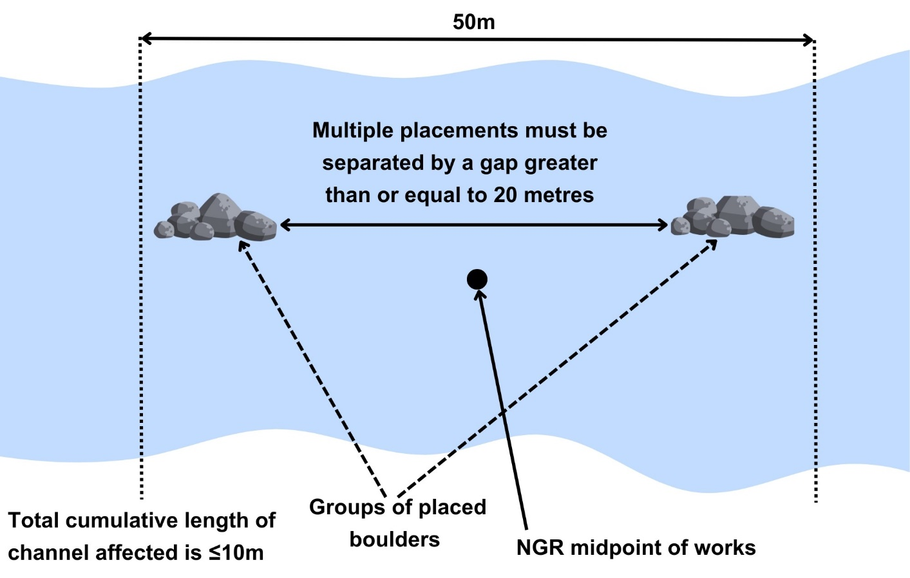
Figure 1: Showing the placement of multiple groups of boulders within a 50 metre length of channel.
Any new bed reinforcement or other instream structure does not require to be registered under this activity where the activity is covered by the scope and/or conditions of another registered or permit level activity. For example, a registration for a new crossing, with part of the crossing on the bed, will cover associated bed reinforcement. Conversely, authorisation under this registration activity, or at a permit level (depending on its scale), is always required for new bed reinforcement at an existing crossing or associated with carrying out new or existing bank works (such as foundations for flood walls).

Key parts of a watercourse
Key parts of a watercourse are shown in Figure 2 and explained in the Glossary
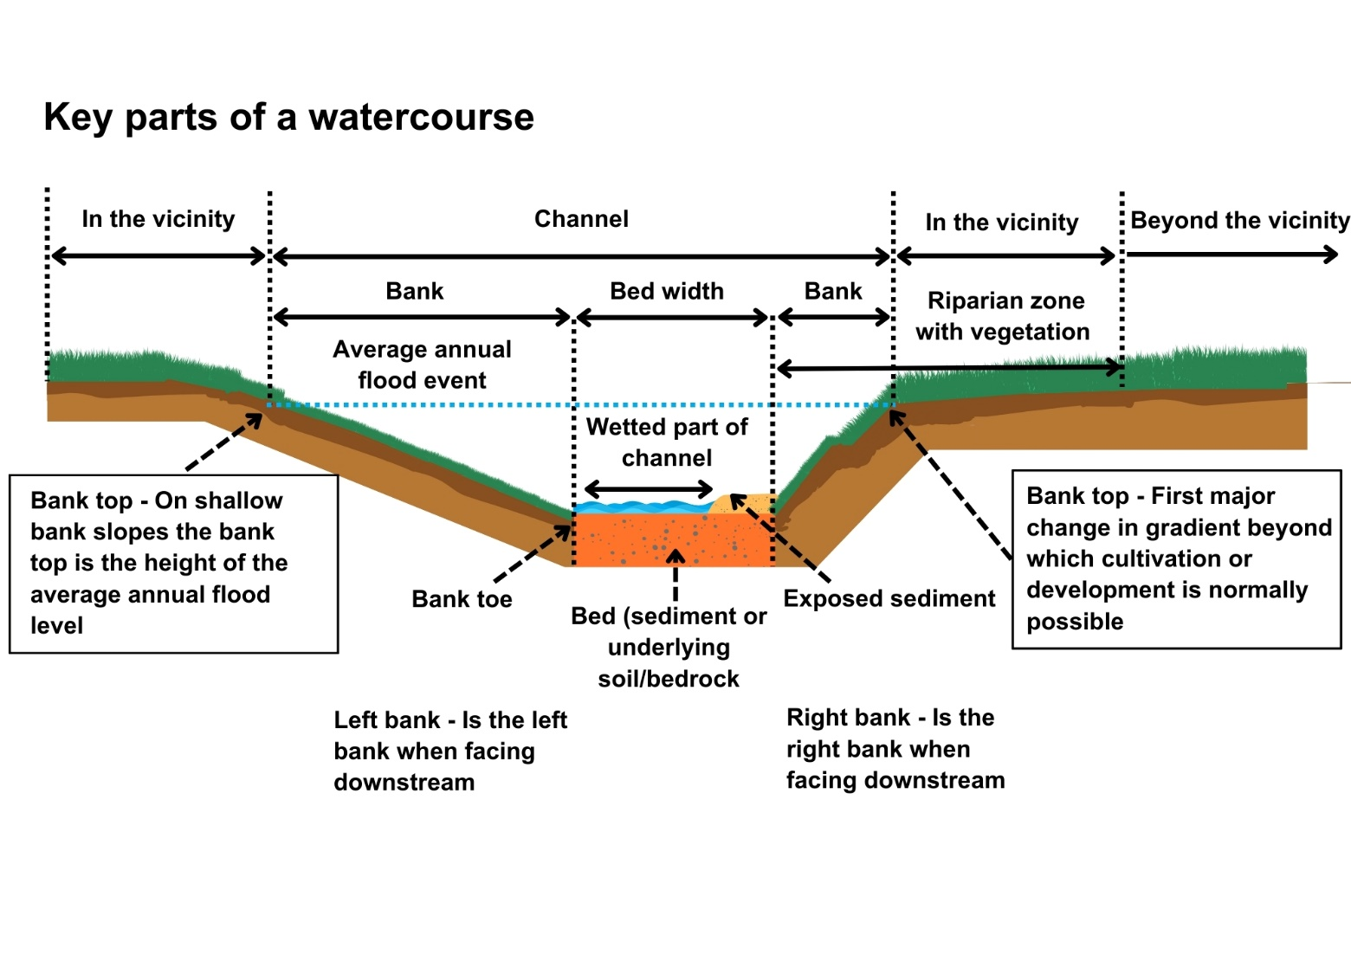
Figure 2: Key parts of a watercourse

Understanding and minimising risks to the water environment
Carrying out this activity and any associated construction works can cause harm to the water environment. It is important to carefully consider your design and construction options to ensure risks to the water environment and other users are minimised and that you fully comply with your standard conditions.
Good practice should be followed in undertaking this activity to ensure environmental harm is minimised, design is sustainable long-term and maintenance requirements are low. To achieve good practice, you should minimise the footprint of the activity and should consider the natural character and processes of the area you are working.
Further information on instream structures can be found in WAT-G-025 EASR Guidance: Engineering: Activity Guide Instream and In-Loch Structures.

Risks to the Water Environment
The main risks to the water environment from carrying out this activity can be grouped as follows:
- Harm to fish
- Including impacts on fish migration, spawning and fry development, loss of habitat and direct impacts such as stranding or physical damage. For more information see WAT-G-008 EASR Guidance: Fish Protection.
- Physical Impacts & Pollution
- Physical impacts to the bed and banks of the watercourse which can lead to instability resulting in increased erosion or deposition, loss of habitats and increased flood risk.
- Pollution from sedimentation, leaking oil from machinery and the entry of potentially polluting materials into water such as unset concrete.
Further information on construction works and mitigation can be found in WAT-G-034 EASR Guidance: Construction works and silt/pollution mitigation.
- Habitats and Species Protection
- Spread of invasive non-native species. Further guidance can be found in EASR-G-001 EASR Guidance: Invasive non-native species (INNS).
- Impacts on species such as freshwater pearl mussels and otter. You should contact NatureScot where your activity is in a Protected area or may impact protected species. For further information see WAT-G-008 EASR Guidance: Assessment of impact on Protected areas from inland water activities.
- Impacts to other users of the water environment.
All the risks to the water environment detailed above will vary according to:
- The type and design of the engineering activity
- The timing of the works.
- The working methods and mitigation.
- The reinstatement methods.
To minimise risks to the water environment and to help you comply with the standard conditions for this activity, you should follow the Do’s and Don’ts below.

Do’s and Don’ts
To minimise risks to the water environment and to help you comply with the standard conditions for this activity, you should follow the do’s and don’ts below:

Activity specific do’s and don’ts
- Don’t alter the bed level. Raising the bed level could impound water or sediment upstream, thus potentially blocking outfalls or increasing flood risk. Lowering the bed level could cause bed and bank erosion to migrate upstream potentially threatening infrastructure and other land uses.
- Don’t alter the bed width. Altering the width can alter erosion and flood risks.
- Don’t create a step in the bed as this could cause a barrier to fish and result in bed and bank erosion to migrate upstream potentially threatening infrastructure and other land uses.
- Do ensure free passage for fish and other wildlife. Make sure any full width bed reinforcement provides sufficient flow depths and velocities for fish to pass easily.

General working in or near water do’s and don’ts
Preventing Harm to Fish
- Don’t undertake works if fish are likely to be spawning or young fish are still to emerge. In general, avoid the period between 1 October to 31 May. You should check the exact times with your local fishery board. Details are available from Fisheries Management Scotland.
- Don’t impact fish migration.
- Do make sure all works such as temporary crossings, channel isolation or diversions, blasting, vibration or pile driving, sheet pilling or using artificial lighting at night so that fish or migrating fish are not adversely affected.
- Do carry out fish rescues, where appropriate etc.
Preventing/ minimising physical and pollution Impacts
- Do install and maintain suitable mitigation before, after and during the works. Including the points below.
- Do minimise the extent, location and duration of works in the wetted part of the channel or loch.
- Do keep vehicles, plant and other equipment out of water wherever possible.
- Do create and maintain a robust and secure dry working area of minimum size, where possible.
- Do minimise disturbance and reinstate banks, bed and vegetation as soon as possible.
  - Minimise vegetation removal and the area of bare earth/ exposed soil.
  - Re-seed or turf disturbed soil with native vegetation and ideally cover with biodegradable matting to provide temporary protection until vegetation is fully established.
- Don’t cause significant erosion.
- Do store all fuel, machinery and vehicles at least 10 metres from any watercourse, loch or permeable drain.
- Do have oil spill kits, drip trays and bunds on site and available to operators.
- Do prevent any pollutants entering the water environment.
Habitats and Species Protection
- Don’t spread invasive non-native species.
- Check the banks and in water for invasive species.
- Use biosecurity measures.
- Do check what other species and habitats may be affected (e.g. otter).
- Don’t harm freshwater pearl mussels.
Other Water Users
- Do consider the potential impacts on other water users e.g. water supplies, fishing, kayaking etc.

Glossary
Terms used in this guidance and supporting diagrams are explained below:
Bank is the side of a watercourse or loch between and including the bank toe and bank top.
Bank Height is the height of the bank of a watercourse or loch measured vertically from the bank toe to the bank top, including any artificial heightening of the bank (e.g. embankments, retaining walls).
Bank Toe is the lowest point on the bank of a watercourse or loch, where the bank meets the bed of the watercourse or loch.
Bank Top is the first major break in slope in the bank or any watercourse or loch.
- This is considered the point beyond which cultivation or development is normally possible. Where there is no clear break in slope the bank top is considered to be the height of the average annual flood level in a watercourse,
- In relation to lochs where there is no clearly definable bank zone the bank top is the line along which terrestrial vegetation is present (this often equates to the average high-water level in a loch).
Bank works are any works on the bank between and including the bank top and the bank toe.
Bed of watercourse is the base of the watercourse, between the toe of one bank and the toe of the opposite bank.
Bed width means the straight-line distance between the opposite bank toes of a river, burn or ditch, and which spans the bed of the river, burn or ditch, including any exposed sediment bars and vegetated islands.
Bed width can be measured as an average along the length of the stretch to be worked or can be based on one measurement of a width that is representative of the stretch.
Beyond the vicinity is the zone that exists beyond the “in the vicinity” zone away from the watercourse or loch.
Channel is the area between the bank top on one side of a river, burn or ditch and the bank top on the opposite side. It includes the banks and bed of a watercourse, including any exposed sediment bars and vegetated islands.
Channel width means the straight-line distance between opposite bank tops of a river, burn or ditch and which spans the bed and banks of a river, burn or ditch, including any exposed bars and vegetated islands.
In the vicinity for a watercourse this is the zone that extends away from the bank top for a distance of 10 metres or two channel widths (whichever is shorter). For a loch this is the zone that extends 10 metres away from the bank top.
Instream Structure means any structure that occupies a portion of the bed of the river, burn, ditch including bed reinforcement, jetties, platforms, marinas, croys, groynes and other flow deflectors, but excluding temporary structures, bridge piers and impounding works.
Left bank is the left bank of a watercourse when facing downstream.
Protected area means an area designated under International (Ramsar sites), European (Special Areas of Conservation and Special Protection Areas) or National (Sites of Special Scientific Interest) legislation, to provide protection of their notable natural features or biodiversity. This legislation places duties on SEPA to assess whether activities we regulate would harm these sites.
Right bank is the right bank of a watercourse when facing downstream.
Riparian zone of a river is the transitional, semi-terrestrial area of land adjoining a river channel (including most of the riverbank) that is regularly inundated and influenced by fresh water and can influence the condition of the aquatic ecosystem (e.g. by shading and leaf litter input).
Sediment refers to the natural material of which the bed of a watercourse or loch is made (includes sand, silt, clay, gravel, cobbles, and boulders).
Temporary crossing (Water Registrations and Permits) is a crossing which will be removed after the completion of the authorised activity.
Temporary structure (Water registrations and Permits) is a structure which will be removed after the completion of the authorised activity.
Wetted part is the part of any watercourse or loch that is wet while carrying out works in a watercourse or loch.

Disclaimer
Whilst every effort has been made to ensure the accuracy of this guidance, SEPA gives no warranty, covenant or undertaking (express or implied) regarding the fitness for purpose of, or any error, omission or discrepancy in this guidance. Reliance on its contents and the contents of any websites that are linked to or from this guidance is entirely at the user’s own risk. SEPA is not liable for any loss or damage that may come from using this guidance. This includes:
- any direct, indirect and consequential losses
- any loss or damage caused by civil wrongs, breach of contract or otherwise.
SEPA reserves the right to depart from this guidance and take appropriate action as it considers necessary or appropriate. Operators are responsible for ensuring that they are compliant with the law. If necessary, independent legal / specialist advice should be sought.

