


WAT-G-014

EASR Guidance:
Version 1.0, August 2025
Registration Activity:
Crossing with part of the crossing on the bed where watercourse bed width is 2 metres or less

Contents
Purpose 2
What activity does this guidance apply to? 2
Understanding the activity 2
Key parts of a watercourse and loch 7
Understanding and minimising risks to the water environment 8
Risks to the Water Environment 10
Dos and Don’ts 11
Activity specific do’s and don’ts 11
General working in or near water dos and don’ts 11
Glossary 14
Disclaimer 17

If you would like this document in an accessible format, such as large print, audio recording or braille, please contact SEPA by emailing equalities@sepa.org.uk

Purpose
This document provides information and guidance for anyone installing a single crossing across a watercourse or loch, where part of the crossing is on the bed and where the watercourse bed width is less than or equal to 2 metres or any loch, which requires a registration, under The Environmental Authorisations (Scotland) Regulations.
This guidance does not cover any other permissions that may be required.

What activity does this guidance apply to?
This guidance applies to engineering activities granted as a registration under the Environmental Authorisations (Scotland) Regulation 2018 for:
The installation of a crossing (excluding crossings with piers, causeways and fords) across a watercourse which has a bed width of less than, or equal to, 2 metres, or a loch where:
- part of the crossing is on the bed; and
- the total cumulative length of channel affected is less than, or equal to, 15 metres; and
- the total cumulative length of all banks affected is less than or equal to 50 metres.

Understanding the activity
This activity is for a single crossing across a watercourse where part of the crossing is on the bed and where the watercourse being crossed has a bed width of 2 metres or less, or any loch.
It includes crossing types such as:
- Single span bridges (where part of the crossing in on the bed).
- Closed culverts – (culverts with an artificial base (invert) typically pipe or box culverts).
- Pipe and cable crossings above or below the watercourse (where part of the crossing is on the bed). This activity includes all associated construction works, such as: access tracks, temporary crossings and temporary structures.
This registration includes the crossing activity and all associated construction works, such as: access tracks, temporary crossings and temporary structures.
This registration does not apply to crossings with piers, causeways, fords and culverts installed for land gain.
Note that ‘part of crossing is on the bed’ refers to the structure of the finished crossing. This may, for example include permanent bed reinforcement or foundations under the bed. It does not include any temporary construction on the bed, such as any excavation required for preparation of abutments, open/isolated cut or mole plough for installing pipe or cable crossings.
The total cumulative length of the bed affected must be no more than 15 metres and the total cumulative length of bank affected must be no more than 50 metres.
All abutments, side walls of culverts etc and any directly associated bank protection works (i.e. immediately upstream and downstream) on both banks are considered to be part of the crossing. This means that for a closed culvert crossing which is 15 metres long a cumulative total of an additional 20 metres of bank protection can be carried out immediately upstream and/or downstream. For example, this could be 5m on each bank at the up and downstream ends of the crossing. This limit does not include, or apply to, the length of any associated temporary bank works
Any artificial base, such as: the invert of pipe and box culverts; bed reinforcement or foundations, must be laid below the existing bed level with natural bed materials placed on top to reinstate existing bed level. Measures to retain the placed bed material during high flows, such as baffles, may be necessary.
We will not allow twin or multiple pipe culverts under registration unless they comply with the standard condition to no alter the bed width. The only way this could be achieve is if the bed width part of the channel is contained in a single pipe and any additional pipes are raised so as to only accommodate flood flows.
The crossing must not create any steps in the bed of the watercourse or loch that can impede the passage of fish and or contribute to erosion of the bed.
Examples of various types of crossing under this registration are shown in figures 1 to 4 below:
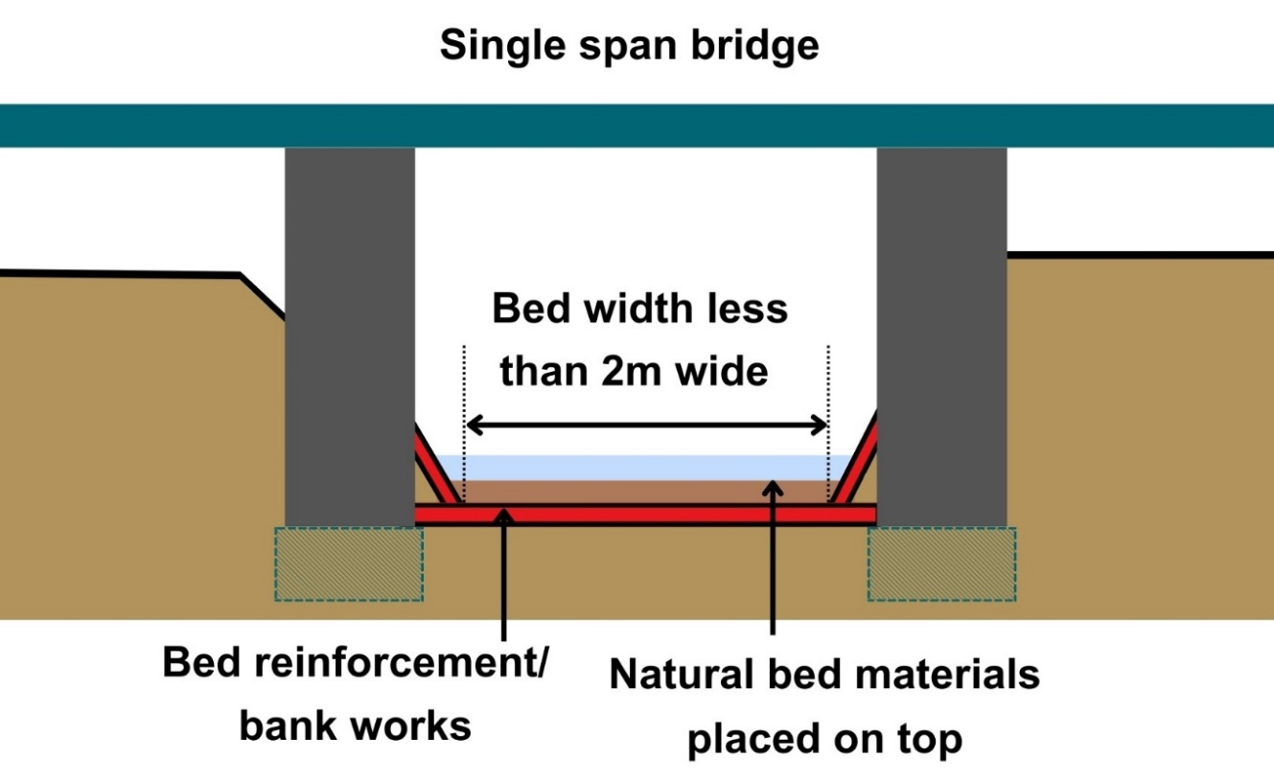
Figure 1: Single span bridge with bed reinforcement and bank works

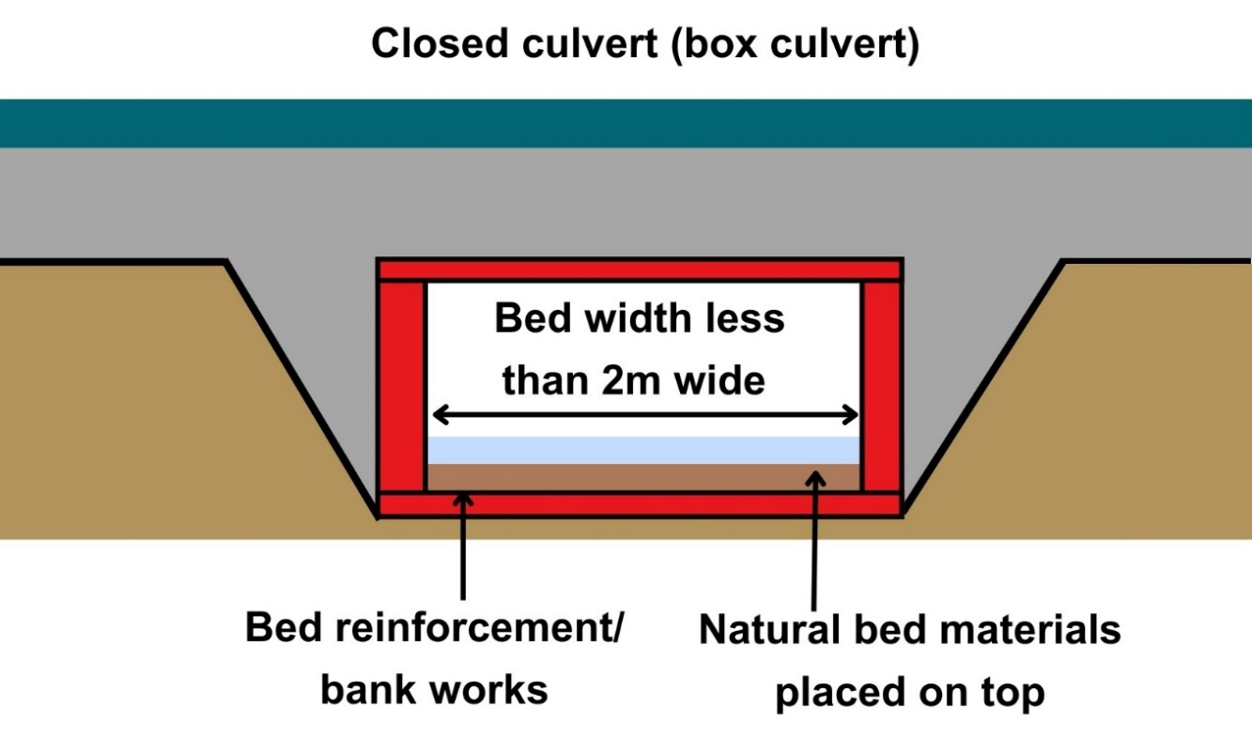
Figure 2: Closed culvert

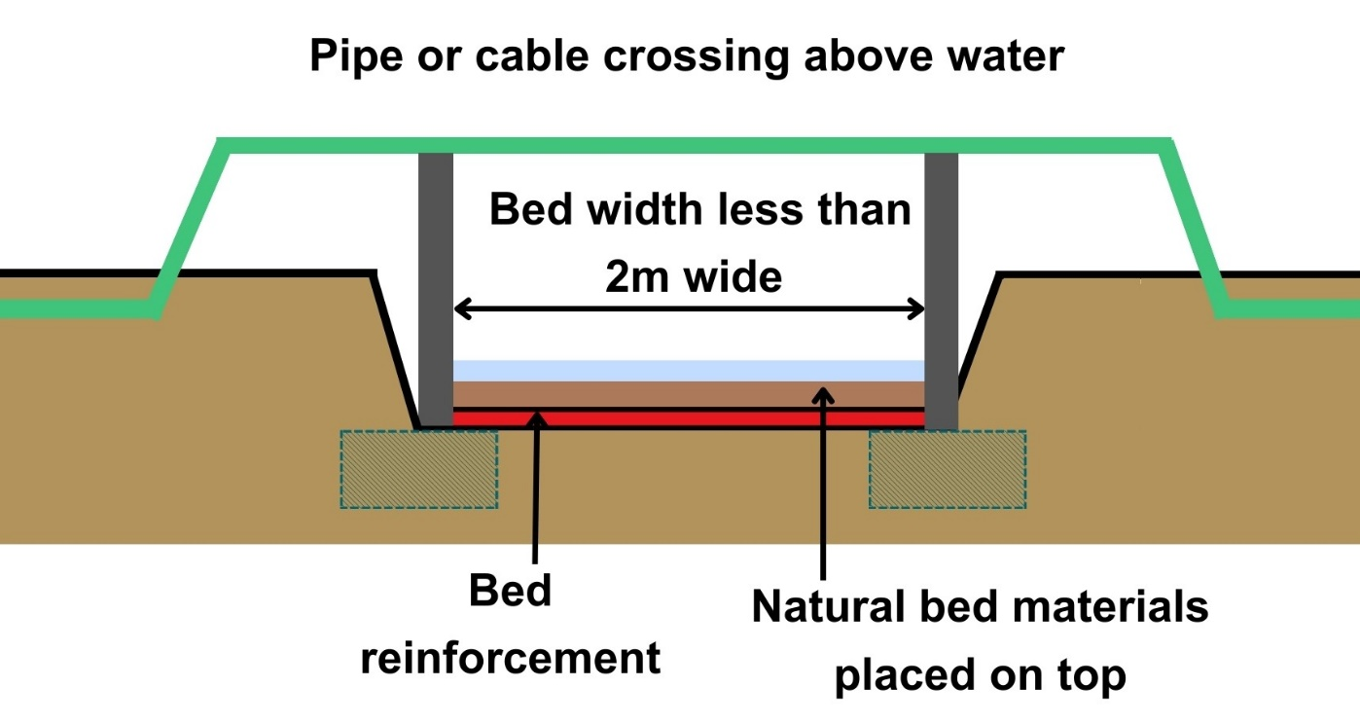
Figure 3: Pipe or cable crossings installed above the bed with bed reinforcement and bank works

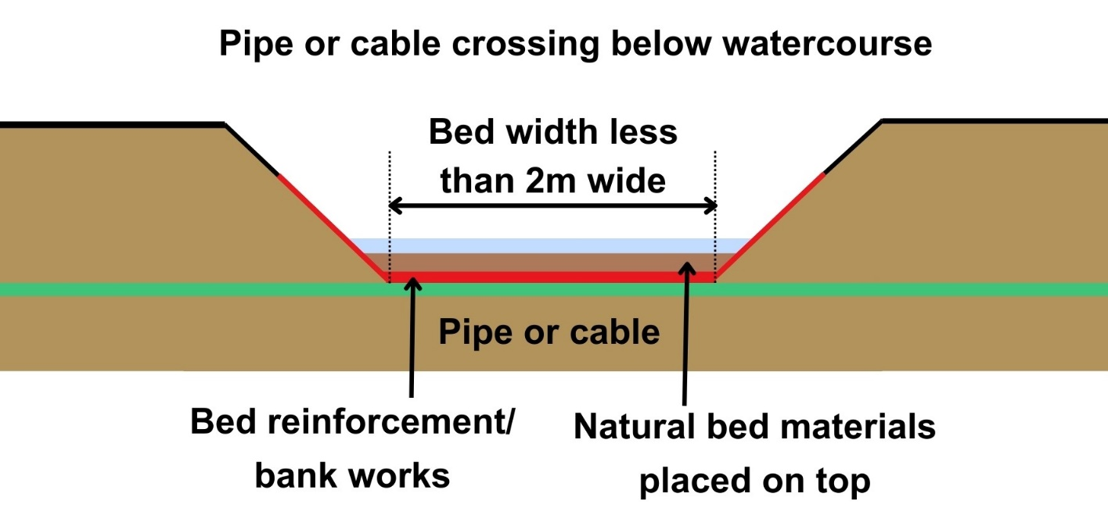
Figure 4: pipe or cable crossings installed below the bed with bed reinforcement and bank works

Key parts of a watercourse and loch
Figures 5 and 6 show the key parts of a watercourse and loch. and explained in the Glossary.
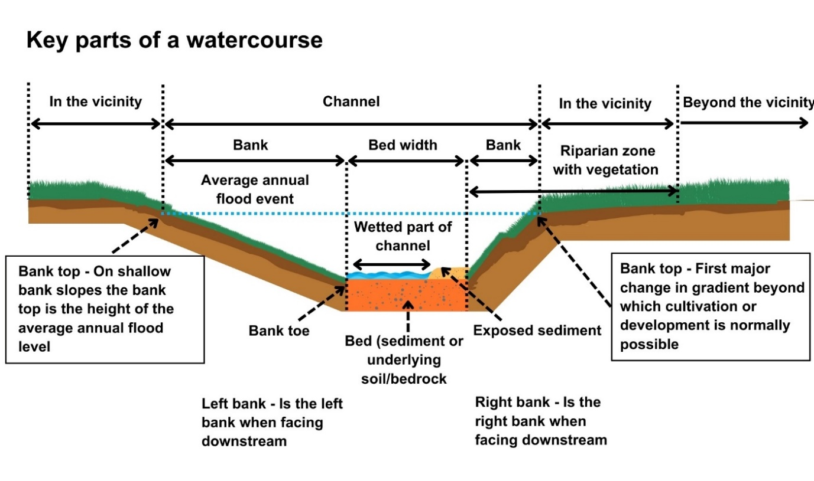
Figure 5: Key parts of a watercourse
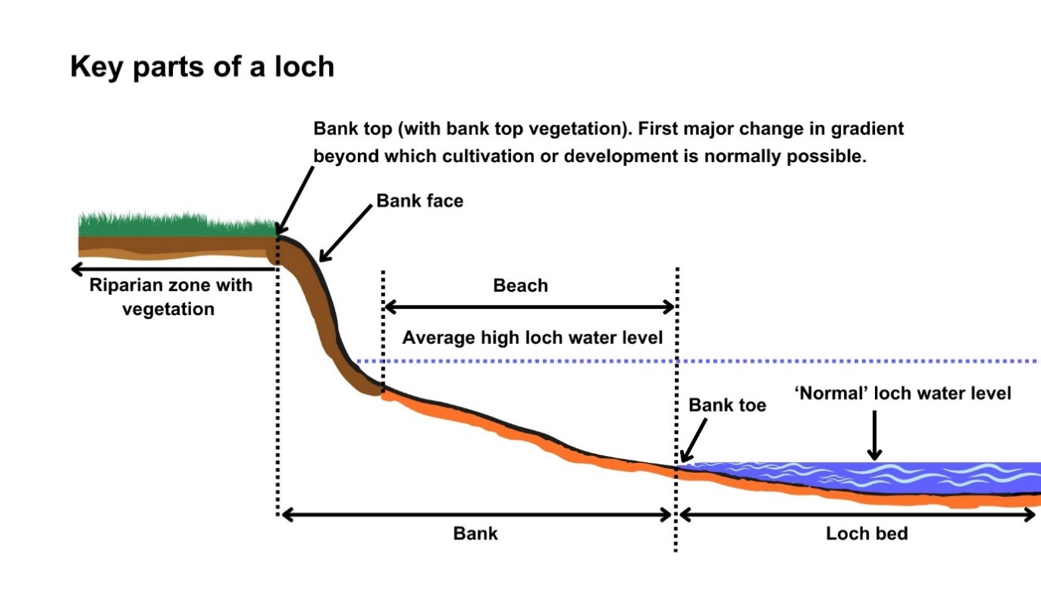
Figure 6: Key parts of a loch

Understanding and minimising risks to the water environment
Installing a crossing and any associated construction works can cause harm to the water environment. It is important to carefully consider your design and construction options to ensure risks to the water environment and other users are minimised and that you fully comply with your standard conditions.
Good practice should be followed in undertaking this activity to ensure environmental harm is minimised, design is sustainable long-term and maintenance requirements are low. To achieve good practice, you should minimise the footprint of the activity and should consider the natural character and processes of the area you are working.
When considering the design, construction and reinstatement of the crossing you should:
- Consider the need. Is a new crossing really needed? Can an existing crossing be used/upgraded?
- Consider the characteristics of the watercourse being crossed. Is the location selected suitable for a river crossing? Might river processes lead to damage to the structure and/or damage to the river in future?
- Identify a range of options and selected the best option.
- Ensure that the final design and construction of the crossing:
- Installs any artificial culvert invert, bed reinforcement or foundations below the existing bed level.
- Places natural bed material on top of the artificial culvert invert, bed reinforcement or foundations (to reinstate bed level and ensure it is not washed out during high flows).
- Does not alter the existing bed width.
- Allows fish, other wildlife, sediment and floating debris (carried during high flows) to easily pass through without acting as a barrier. Aim to design and construct crossings that do not significantly alter existing velocities or create sudden changes in velocity. Particular attention should be paid to flow velocities at the inlet and outlet).
- Has no step in the bed at the inlet and outlet of the crossing and that these do not develop over time.
- Takes into account anticipated increases in flow, erosion and deposition as a result of climate change.
- Plan and design to minimise the risks to the water environment and other users.
- Follow the dos and don’ts listed below.
Further information on crossings and sustainable design can be found in WAT-G-024 EASR Guidance: Engineering: Activity Guide Crossings.

Risks to the Water Environment
The main risks to the water environment from carrying out this activity can be grouped as follows:
- Harm to fish
  - Including impacts on fish migration, spawning and fry development, loss of habitat and direct impacts such as stranding or physical damage. For more information see WAT-G-032 EASR Guidance: Fish Protection.
- Physical Impacts & Pollution
  - Physical impacts to the bed and banks of the watercourse which can lead to instability resulting in increased erosion or deposition, loss of habitats and increased flood risk.
  - Pollution from sedimentation, leaking oil from machinery and the entry of potentially polluting materials into water such as unset concrete.
  - Further information on construction works and mitigation can be found in WAT-G-034 EASR Guidance: Construction works and silt/pollution mitigation.
- Habitats and Species Protection
  - Spread of invasive non-native species. Further guidance can be found in EASR Guidance: Invasive non-native species (INNS).
  - Impacts on species such as freshwater pearl mussels and otter. You should contact NatureScot where your activity is in a Protected area or may impact protected species. For further information see WAT-G-008 EASR Guidance: Assessment of impact on Protected areas from inland water activities.
- Impacts to other users of the water environment.

All the risks to the water environment detailed above will vary according to:
- The type and design of the engineering activity.
- The timing of the works.
- The working methods and mitigation.
- The reinstatement methods.
To minimise risks to the water environment and to help you comply with the standard conditions for this activity, you should follow the Do’s and Don’ts below.

Dos and Don’ts

Activity specific do’s and don’ts
- Don’t alter the bed width. Altering the width can alter erosion/deposition patterns and flood risk.
- Do ensure any artificial culvert base (invert), bed reinforcement or foundations are laid below the existing bed level and ensure natural bed materials are placed on top and can be retained.
- Don’t create a step in the bed.
- Do ensure the crossing allows for free passage for fish, other wildlife, sediment and floating debris.
- Do provide sufficient flow capacity and design the capacity of crossing to take account of increased flows and the resulting increase in erosion, transport and deposition of sediment due to climate change.

General working in or near water dos and don’ts
Preventing Harm to Fish
- Don’t undertake works if fish are likely to be spawning or young fish are still to emerge. In general, avoid the period between 1 October to 31 May. You should check the exact times with your local fishery board. Details are available from Fisheries Management Scotland.
- Don’t impact fish migration.
- Do make sure all works such as temporary crossings, channel isolation or diversions, blasting, vibration or pile driving, sheet pilling or using artificial lighting at night so that fish or migrating fish are not adversely affected.
- Do carry out fish rescues, where appropriate etc.
Preventing/ minimising physical and pollution Impacts
- Do install and maintain suitable mitigation before, after and during the works. Including the points below.
- Do minimise the extent, location and duration of works in the wetted part of the channel or loch.
- Do keep vehicles, plant and other equipment out of water wherever possible.
- Do create and maintain a robust and secure dry working area of minimum size, where possible.
- Do minimise disturbance and reinstate banks, bed and vegetation as soon as possible.
  - Minimise vegetation removal and the area of bare earth/ exposed soil.
  - Re-seed or turf disturbed soil with native vegetation and ideally cover with biodegradable matting to provide temporary protection until vegetation is fully established.
- Don’t cause significant erosion.
- Do store all fuel, machinery and vehicles at least 10 metres from any watercourse, loch or permeable drain.
- Do have oil spill kits, drip trays and bunds on site and available to operators.
- Do prevent any pollutants entering the water environment.
Habitats and Species Protection
- Don’t spread invasive non-native species.
- Check the banks and in water for invasive species.
- Use biosecurity measures.
- Do check what other species and habitats may be affected (e.g. otter).
- Don’t harm freshwater pearl mussels.
Other Water Users
- Do consider the potential impacts on other water users e.g. water supplies, fishing, kayaking etc.

Glossary
Terms used in this guidance and supporting diagrams are explained below:
Bank is the side of a watercourse or loch between and including the bank toe and bank top.
Bank Height is the height of the bank of a watercourse or loch measured vertically from the bank toe to the bank top, including any artificial heightening of the bank (e.g. embankments, retaining walls).
Bank Toe is the lowest point on the bank of a watercourse or loch, where the bank meets the bed of the watercourse or loch.
Bank Top is the first major break in slope in the bank or any watercourse or loch.
- This is considered the point beyond which cultivation or development is normally possible. Where there is no clear break in slope the bank top is considered to be the height of the average annual flood level in a watercourse,
- In relation to lochs where there is no clearly definable bank zone the bank top is the line along which terrestrial vegetation is present (this often equates to the average high-water level in a loch).
Bank works are any works on the bank between and including the bank top and the bank toe.
Beach is lower part of the bank of a loch (note in some cases the beach may form all of the bank)
Bed of watercourse is the base of the watercourse, between the toe of one bank and the toe of the opposite bank.
Bed of loch is the base of the loch extending from the deepest part of the loch to the edge of the ‘normal’ loch water level.
Bed width means the straight-line distance between the opposite bank toes of a river, burn or ditch, and which spans the bed of the river, burn or ditch, including any exposed sediment bars and vegetated islands.
Bed width can be measured as an average along the length of the stretch to be worked or can be based on one measurement of a width that is representative of the stretch.
Beyond the vicinity is the zone that exists beyond the “in the vicinity” zone away from the watercourse or loch.
Bridge is a span structure used for crossing a watercourse or loch. The structure can sometimes be supported on piers.
Channel is the area between the bank top on one side of a river, burn or ditch and the bank top on the opposite side. It includes the banks and bed of a watercourse, including any exposed sediment bars and vegetated islands
Channel width means the straight-line distance between opposite bank tops of a river, burn or ditch and which spans the bed and banks of a river, burn or ditch, including any exposed bars and vegetated islands.
Closed Culvert is a culvert with an artificial base (typically pipe or box culverts)
Crossing (for crossing registration activities) means any structure which is constructed and installed for the purpose of supporting a footpath, cycle route or transport route across any river, burn, ditch or loch or any pipe, pipeline or cable which crosses over or underneath any river, burn, ditch or loch, but excluding crossings with instream or in-loch piers, causeways , fords, temporary crossings, impounding works and culverts installed for land gain.
High loch water level is the average water level typically reached during wet periods.
In the vicinity for a watercourse this is the zone that extends away from the bank top for a distance of 10 metres or two channel widths (whichever is shorter). For a loch this is the zone that extends 10 metres away from the bank top.
Left bank is the left bank of a watercourse when facing downstream.
Loch is a body of standing inland surface water.
Normal loch water level is the water level that occurs for a large part of the year when the loch is not experiencing high water levels. Higher than the minimum water surface elevation.
Protected area means an area designated under International (Ramsar sites), European (Special Areas of Conservation and Special Protection Areas) or National (Sites of Special Scientific Interest) legislation, to provide protection of their notable natural features or biodiversity. This legislation places duties on SEPA to assess whether activities we regulate would harm these sites.
Right bank is the right bank of a watercourse when facing downstream.
Riparian zone of a river is the transitional, semi-terrestrial area of land adjoining a river channel (including most of the riverbank) that is regularly inundated and influenced by fresh water and can influence the condition of the aquatic ecosystem (e.g. by shading and leaf litter input).
Riparian zone of a loch is the area of land extending from the bank top or the limit of terrestrial vegetation and capable of directly influencing the condition of the aquatic ecosystem (e.g. by shading and leaf litter input)
Sediment refers to the natural material of which the bed of a watercourse or loch is made (includes sand, silt, clay, gravel, cobbles and boulders).
Temporary crossing (Water Registrations and Permits) is a crossing which will be removed after the completion of the authorised activity.
Temporary structure (Water registrations and Permits) is a structure which will be removed after the completion of the authorised activity.
Wetted part is the part of any watercourse or loch that is wet while carrying out works in a watercourse or loch.

Disclaimer
Whilst every effort has been made to ensure the accuracy of this guidance, SEPA gives no warranty, covenant or undertaking (express or implied) regarding the fitness for purpose of, or any error, omission or discrepancy in this guidance. Reliance on its contents and the contents of any websites that are linked to or from this guidance is entirely at the user’s own risk. SEPA is not liable for any loss or damage that may come from using this guidance. This includes:
- any direct, indirect and consequential losses
- any loss or damage caused by civil wrongs, breach of contract or otherwise
SEPA reserves the right to depart from this guidance and take appropriate action as it considers necessary or appropriate. Operators are responsible for ensuring that they are compliant with the law. If necessary, independent legal / specialist advice should be sought.

